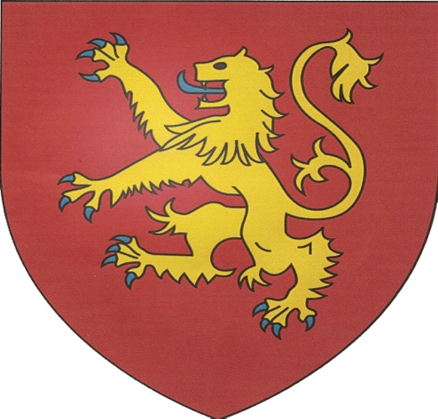

Archaeological and historical investigation of royal site at Tidgrove in Hampshire

Tidgrove is located 12 miles to the west of Basingstoke and is situated about half way along the road from Kingsclere to Overton. From the pipe rolls it has long been known that in 1172 Henry II built ‘the king’s houses’ there, but until about thirteen years ago the actual site had not been identified.
In the nineteen twenties, Mr. Bull, a Kingsclere schoolmaster observed, in a corn crop, the outline of a large enclosure which he thought to be Roman. The existence of the enclosure has been confirmed by aerial photography, and its size of the enclosure, when compared with those of known medieval hunting lodges such as Writtle in Essex, suggested that this could be the site of Henry’s buildings. The landowner, Raleigh Place, his historian the late Rev. Robert Legg, and the Kingsclere Heritage Association thought that archaeological investigation would be worthwhile, and were fortunate in gaining the interest of the archaeological department of Southampton University.
Under the direction of Kristian Strutt and Professor David Hinton investigation of the site was begun, with the support of volunteers from the Kingsclere Heritage Association and the landowner.

Kris Strutt and David Hinton have written:
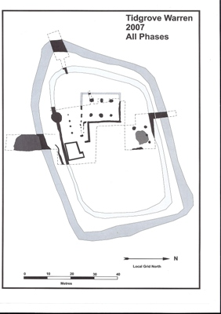
The University of Southampton has now completed the forth year of fieldwork on Tidgrove Warren. The work was concentrated on the ditched enclosure that has been shown in 2005 to be the site of the royal houses there on which Henry spent money in the 1170s. Its wide and deep ditch showed that a lot of time and effort went into its construction, and a cellar was identified. The year’s work as showed that the cellar was a grand structure; it had plastered flint lining walls, up to 8 feet deep. And a side entrance with stone-lined stairs. It probably had a stone barrel-vaulted roof with buildings above it. Elsewhere on the site, very large post-holes and as rammed chalk deposit were found, the latter confirming the experimental ground-penetrating radar survey in the spring; another section ditch proved as large as the one excavated in 2005, but with an added complication - the edge of what seems to have been another deep ditch. Not quite on the same line.

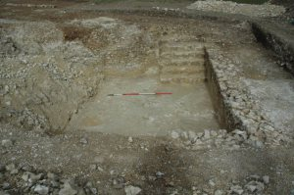
Tidgrove’s royal residence was much more than the expected few timber buildings for occasional use The cellar (seen below) seems as large and substantial as one at Clarendon Palace; the ditch is deeper and wider than at some castles; and the enormous post-holes indicate building on a large scale.

It seems unlikely now that all this work was done only in the 1170s, and that the site was then abandoned for ‘Freemantle’, on which money was spent in the 1180s. Instead the residence may have been renamed and Robert Legg has suggested that it could have been used to the end of King John’s reign. Maybe only in the 1250s, when a park for fallow deer was constructed around Cottingtons Hill, was a house built up there on the summit (where survey in April 07 indicated buildings, but possibly all part of the large mansion built in 1700’s)

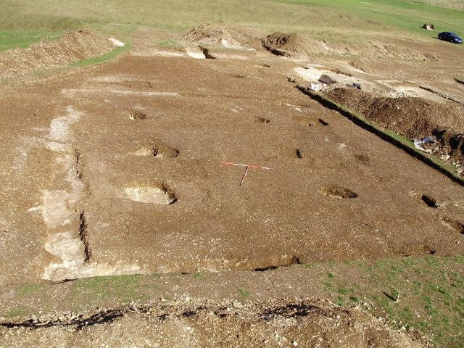
Henry II builds houses at Tidgrove
Henry was not only King of England and lord of Ireland, but also duke of Normandy, duke of Aquitaine and count of Anjou. He spent more time in his French possessions than in England, some 20 years in France as against 13 ½ in England, Wales and Ireland. In all he crossed the Channel at least twenty-eight times. The two places routinely visited in England were the treasury at Winchester, and the Exchequer at Westminster, which was the administrative capital whilst the King was out of the country. When in England the royal household probably numbered one hundred and fifty persons or more, and was accompanied by wagons and pack horses for the wardrobe and other heavy goods. This limited progress to about twenty miles a day. The route normally followed was Portsmouth, Winchester, Wolverton or Tidgrove/Freemantle, Reading, Windsor to Westminster.

Great Hall during excavation

The Royal Household at this time
The household was necessarily peripatetic since it enabled the king to personally supervise affairs, and since it was a substantial body it was easer to take it where the food was than to bring supplies to it, and it gave the king new hunting grounds, a sport in which he delighted. The household was divided between the chancery, and the departments of the chamberlain, steward, butler, and marshal. The various departments included a host of greater or less servants, writers. bakers, scullions, guards, huntsmen, falconers and so on. Some idea of the organisation of the household can be gained from a document prepared after the death of Henry I to give guidance to Stephen.
Bartlett in his comments on the royal household says:
Such an itinerant household had to be portable. In the treatise on ‘The Organisation of the King’s Household’ there is mention of ‘the bearer of the king’s bed’ and ‘the tent-keeper’, each with his servant and pack-horse,. which were assigned also to the napier (who was responsible for the linen) to the keeper of the tables, and to the scullions of the king’s kitchen and the great kitchen, who were responsible for the bowls and dishes. The chaplain and the sergeant of the buttery each had two pack-horses, while carters are mentioned for the great kitchen, larder and buttery. Forward planning was essential: two of the king’s four bakers were always sent ahead to prepare bread for the next day.
Peter of Blois, at one time secretary to Henry, in a letter to the bishop of Palermo, paints a picture of life in the household:
If the king has said he will remain in a place for a day - and particularly has announced his intention publicly by the mouth of a herald - he is sure to upset all the arrangements by departing early in the morning. And you then see men dashing around as if they were mad, beating packhorses, running carts into one another - in short, giving a lively imitation of Hell. If, on the other hand, the king orders an early start, he is sure to change his mind, and you can take it for granted that he will sleep until midday. Then you will see the packhorses loaded and waiting, the carts prepared, the courtiers dozing, traders fretting, and everyone grumbling. People go to ask the maids and doorkeepers what the king’s plans are, for they are the only ones likely to know the secrets of the court. Many a time when the king was sleeping, a message would be passed from his chamber about a city or town he intended to go to, and though there was nothing certain about it, we would be comforted by the prospect of good lodgings. This would produce such a clatter of horse and foot that all Hell seemed let loose. But when our courtiers had gone ahead almost the whole day’s ride, the king would turn aside to some other place where he had, it might be, just a single dwelling with accommodation for himself and no one else.
I hardly dare say it, but I believe that in truth he took a delight in seeing what a fix he put us in. After wandering some three or four miles in an unknown wood, and often in the dark, we thought ourselves lucky if we stumbled upon some filthy hovel. There were often a sharp and bitter argument about a mere hut, and swords were drawn for possession of lodgings, which pigs would have shunned.
It was not only in domestic matters that the king’s will was paramount, but when it was said “The king has ordered!” it was not a decision by the curia regis, an ad hoc body of those who were present at the time, whom the king chose to consult, but very much a decision of the king himself.

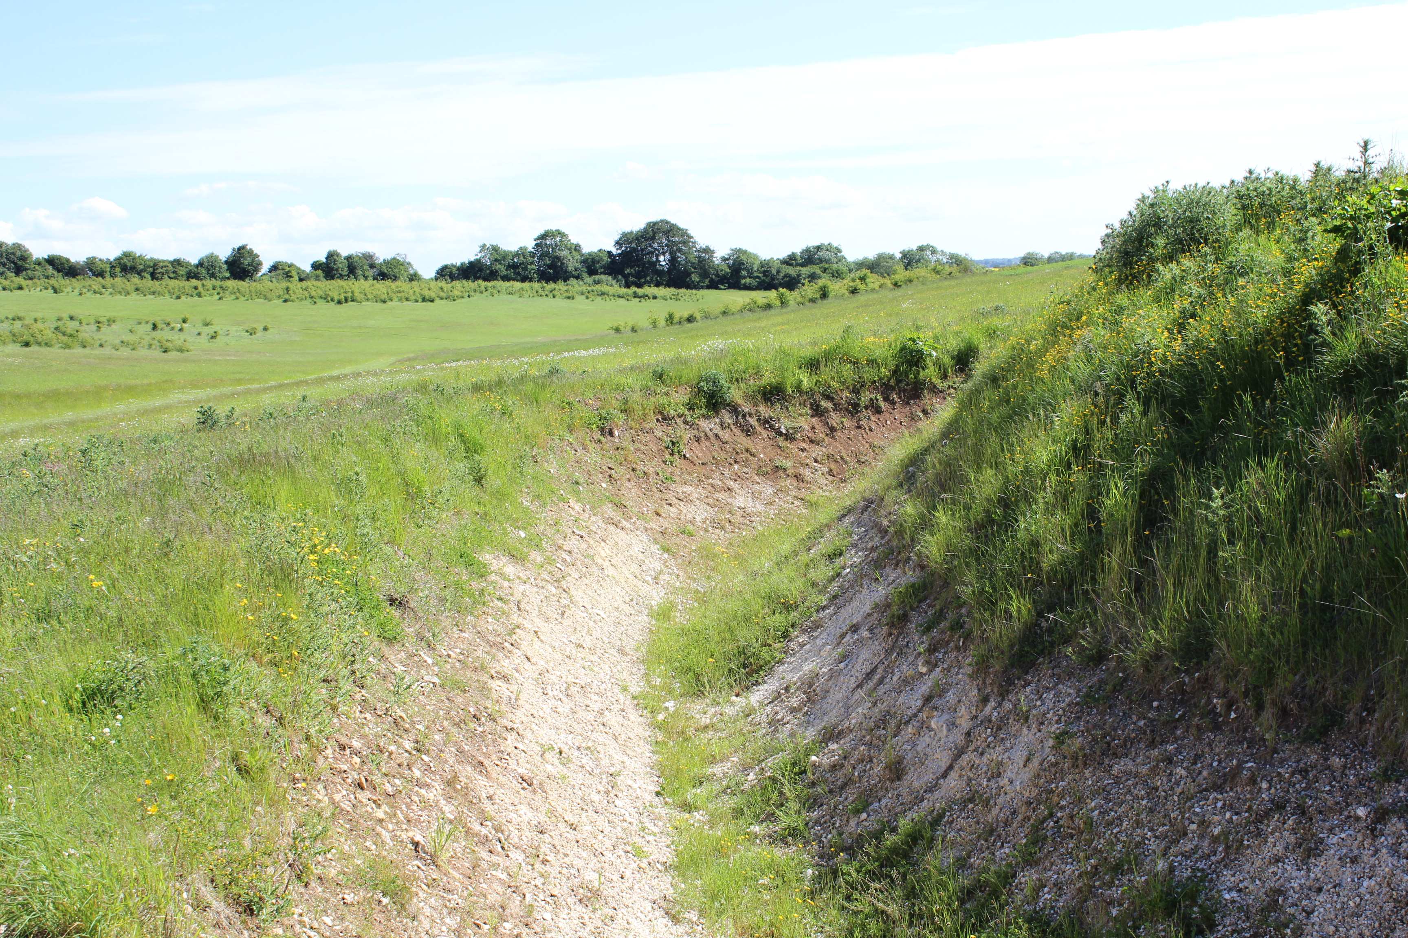

View of ditch on east side from gatehouse position

In 1171 Henry visited England and Wales and went on to sort out affairs in Ireland, returning to France in May 1172. The journey would have included a stay at Wolverton which, despite the fact that it had been regularly maintained, for some reason he found unsatisfactory. He gave orders for the building of new houses at Tidgrove, and in 1172 the sheriff of Hampshire claimed for: work on the king’s houses at Tidgrove £31 9s. 7d. by the king’s writ.
The site chosen lay close to the well used road from Winchester to Reading, Windsor, and London, later described as the king’s highway, and was either on the edge of Witingley Forest or just within its bounds. Furthermore the site was favoured with a stream, a small tributary of the river Test which has now disappeared. The writ has not survived but the general form of such writs is known and it would have said, following the style of the earliest surviving example of such a document.
Henry, by the grace of God King of England, lord of Ireland, Duke of Normandy and Aquitaine, and count of Anjou, to the sheriff of Hampshire, greeting. We command you that as soon as you have read these letters you build our houses at Tidgrove against our coming by the view and testimony of law-worthy men, and the expense shall be allowed to you at the Exchequer. Witness myself at Tidgrove the ------- day of --------, in the year of our reign.
It will be seen that it contains no details of the work. In general such work was carried out by local craftsmen under the supervision of the sheriff, and its satisfactory conclusion certified by ’viewers’, quite unqualified in a technical sense, but ‘law worthy‘ men. Further work at Tidgrove is described in subsequent pipe rolls: 1177, work on the king’s chapel at Tidgrove £7 16s. 1178, work on the king’s houses at Tidgrove £24 18s. 7d.. After 1181 there are no further references to the king’s houses at Tidgrove, but the name Freemantle is consistently used. In 1181 timber was taken from the forest of Knepp in Sussex to Freemantle and Clarendon as is shown by the Pipe Roll of that year. Then in 1182 work on the king’s houses at Freemantle at a cost of £118 4s was recorded. There is nothing to indicate that this was a new site for the king’s houses, but traditionally Freemantle has been identified with a place on Cottington’s Hill where in the eighteenth century a gentleman of that name built a house.
A visitor to this site in 1700’s commented thus
“Yesterday we went to see a very extraordinary place. A gentleman has built a house on the summit of a prodigious hill, where there is not a drop of water nor a stick of wood; he has planted some fir trees which are watered every day by carts that bring the water about three miles; he has sunk a well to the centre of the earth, from whence some laborious horses draw him as much water as may wash his face, or in a liberal hour supply his tea kettle. The wind plays about his house in so riotous a manner, that a person must poise themselves in a very exact manner to maintain their ground and walk on two legs as it is the glory and pride of human nature to do…”
Mrs Elizabeth Montagu, Sandleford Priory August 2nd 1747
The question must be asked, “Why, after ten years of occupation should Tidgrove be abandoned?” Freemantle, as later identified, was two miles north of Tidgrove, was less accessible, and as Cottington discovered when he built a house there in the eighteenth century, lacked a decent water supply, and no certain archaeological evidence has been identified to indicate a high status residence. The most probable and simple explanation is that by the king’s fiat both the houses and the forest were renamed. This has been obscured because these earlier royal houses, wherever they were, were abandoned after the death of John, but the site on Cottington’s Hill was firmly fixed in the popular mind because in 1251 Henry III gave orders for new houses consisting of a hall, kitchen, chambers for himself and the queen on the first floor, with a chapel at one end, under which there was to be a wine cellar. These, together with the deer park he laid out alongside the houses, would naturally be described as being at Freemantle.

The Origin of the Place Name Freemantle
Coates derives the Hampshire place-name Freemantle from the French place-name Fromental. There are numerous place names in modern France which contain the word Fromental, but the only one which has justified serious pursuit is Fromental in the ancient county of La Marche. In December 1177, whilst at Grandmont, Henry purchased the county of La Marche for 60,000 marks and 20 mules and 20 palfreys, the purchase being concluded at the abbey of Grandmont, whereupon the barons of the county had done ‘homage and fealty’ to Henry as their liege-lord. Henry had a particular affection for Grandmont. He was lavish in his support of the abbey, and frequently visited and took counsel with the austere monks there, particularly during the controversy with Becket. The abbey was included in the bequests he made in his last testament, and he even expressed a wish to be buried at Grandmont, though in fact he came to rest at Fontevrault. Fromental lay just 18 kilometres to the north. of Grandmont.

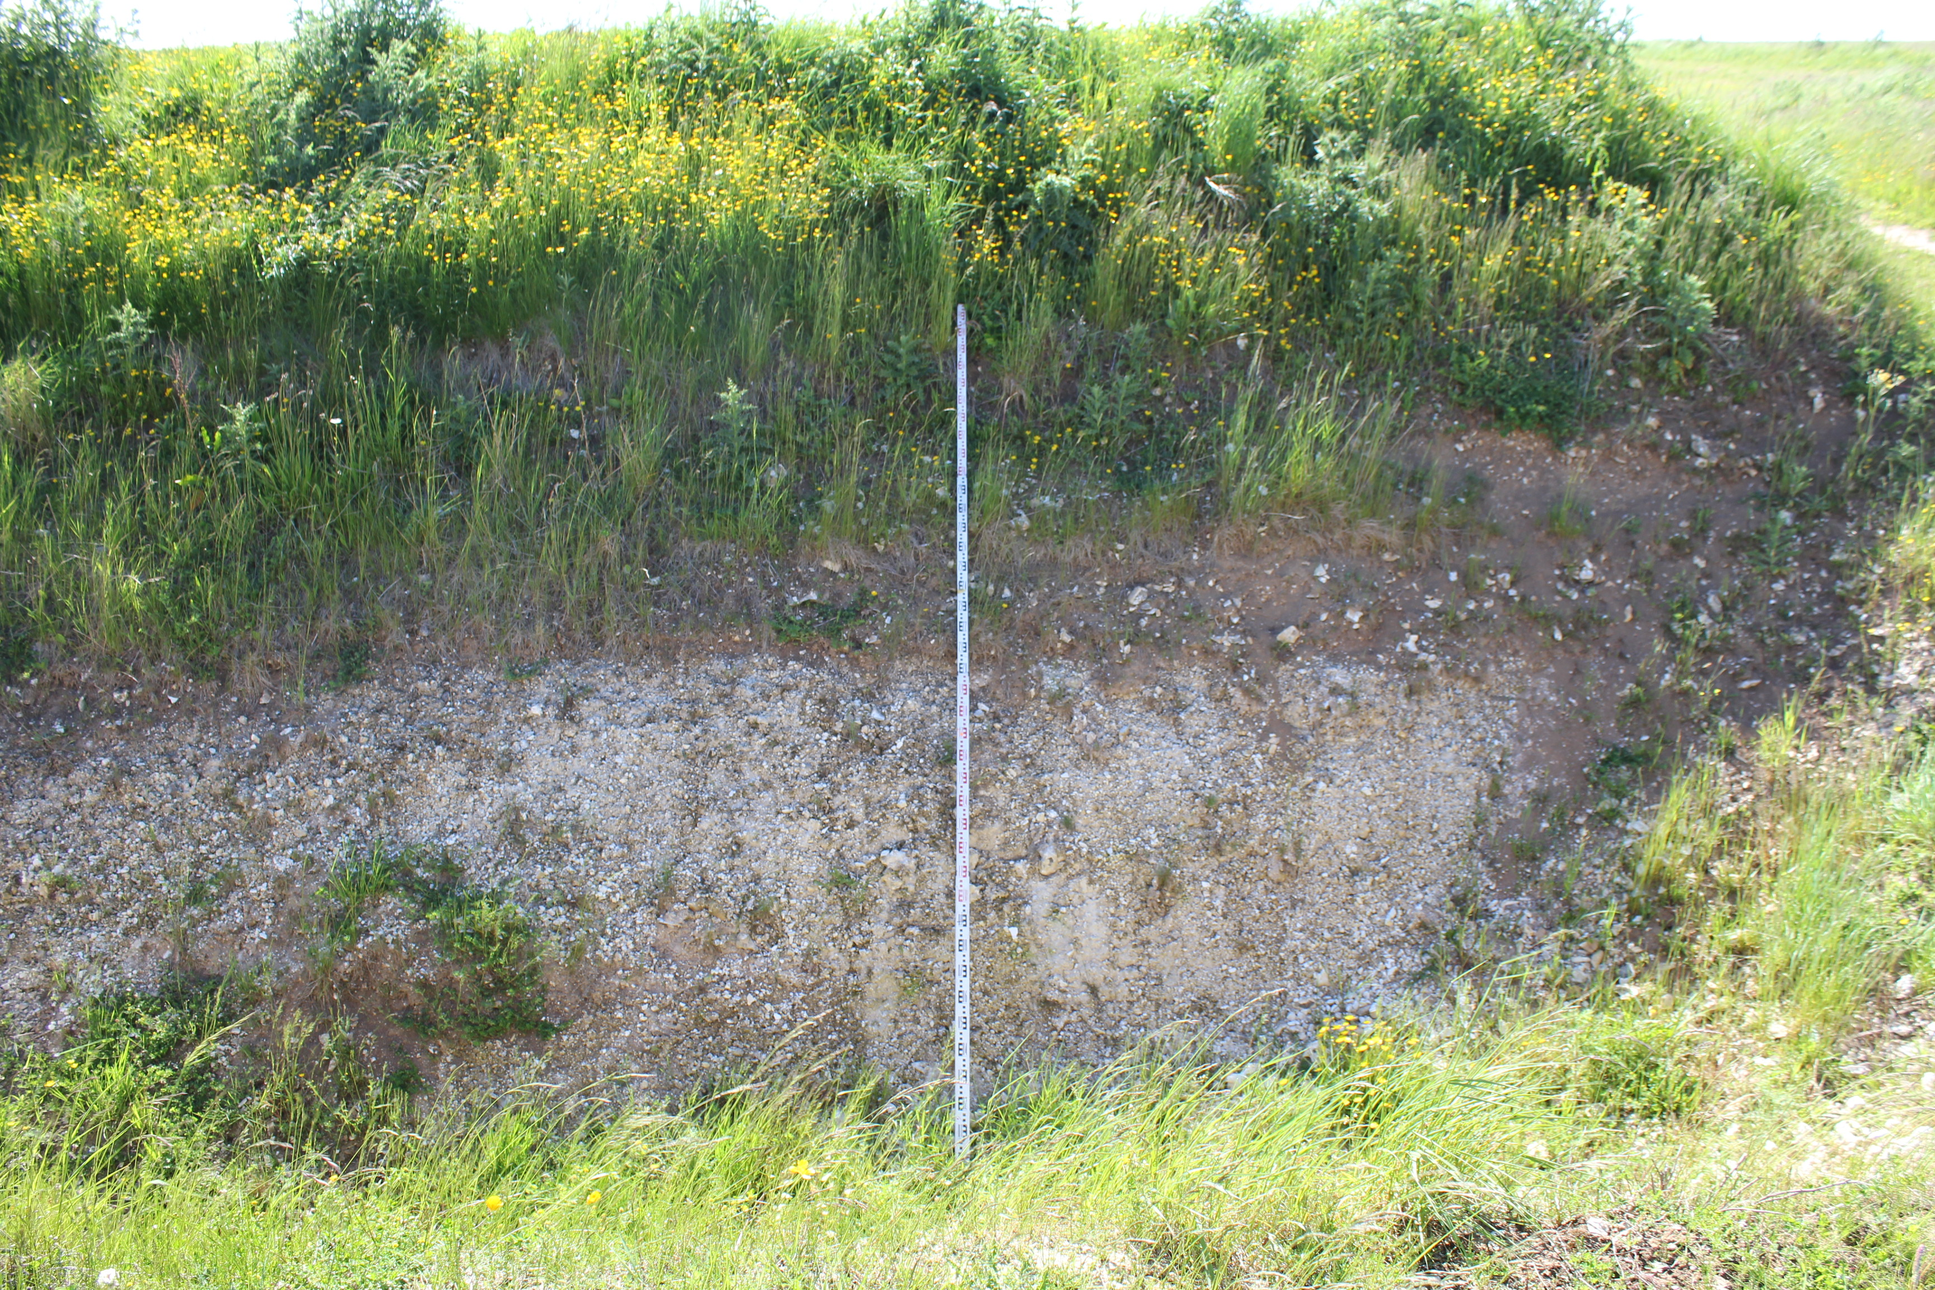
View showing depth of ditch on east side in excess of 4 metres

Henry made at least three visits to Tidgrove after his return from France in August 1177, the last of which was in April 1180 when he was on his way from Reading to Winchester in order to embark at Portsmouth. It must have been then that he gave orders for the carriage of timber to Freitmantell, and for building work to be done there‘. The crucial question is where was Freitmantell for there is no evidence for a place of that name before 1181. It seems probable that the king chose to rename both the forest of Witingley and his houses there as Fromental, which the clerks recorded as Freemantle in various forms.
Work on the site in recent years has sought to further define the date of the Great Hall, possibilities range from 1170’s to 1250’s.
Close examination of the six main post holes indicate use of stone plinths as opposed to earthbound posts, this tends to suggest the later date, the ratio between aisle and the and nave width indicates a roof pitch around 50 degrees, ok both for thatch and shingles. Examination of the Pipe Rolls shows use of shingles at Freemantle in 1254 and purchase of lead and tin.
The floor of hall indicates a paved surface as opposed to earth as in the earlier hall on site, where remains of sunken central hearth showed a variety of bones from deer, oxen pig, sheep, and fowl

New historical evidence of the continuing use of the house at Tidgrove has been discovered within a poem written by the French Troubadour Bertran de Born in 1189-90 (translation from Provencal by James H Donalson) Notes by Raleigh Place

ANC NOS POC FAR MAJOR ANTA (THOUGH THERE CAN BE GREATER SHAME)
Verse the Sixth.
Ves mon Oc-e-No t’avanta, Go forward to my Yea-and-Nay, ^{rp1}
Papiols, Padiol,
Quar seus es Bristols, For Bristol-town is his,
E Nortensems e Susest, Northampton and Sussex too,
E Londres e Titagrava, And London and Titgrave as well,
E Carais, Carhaix in Brittany,
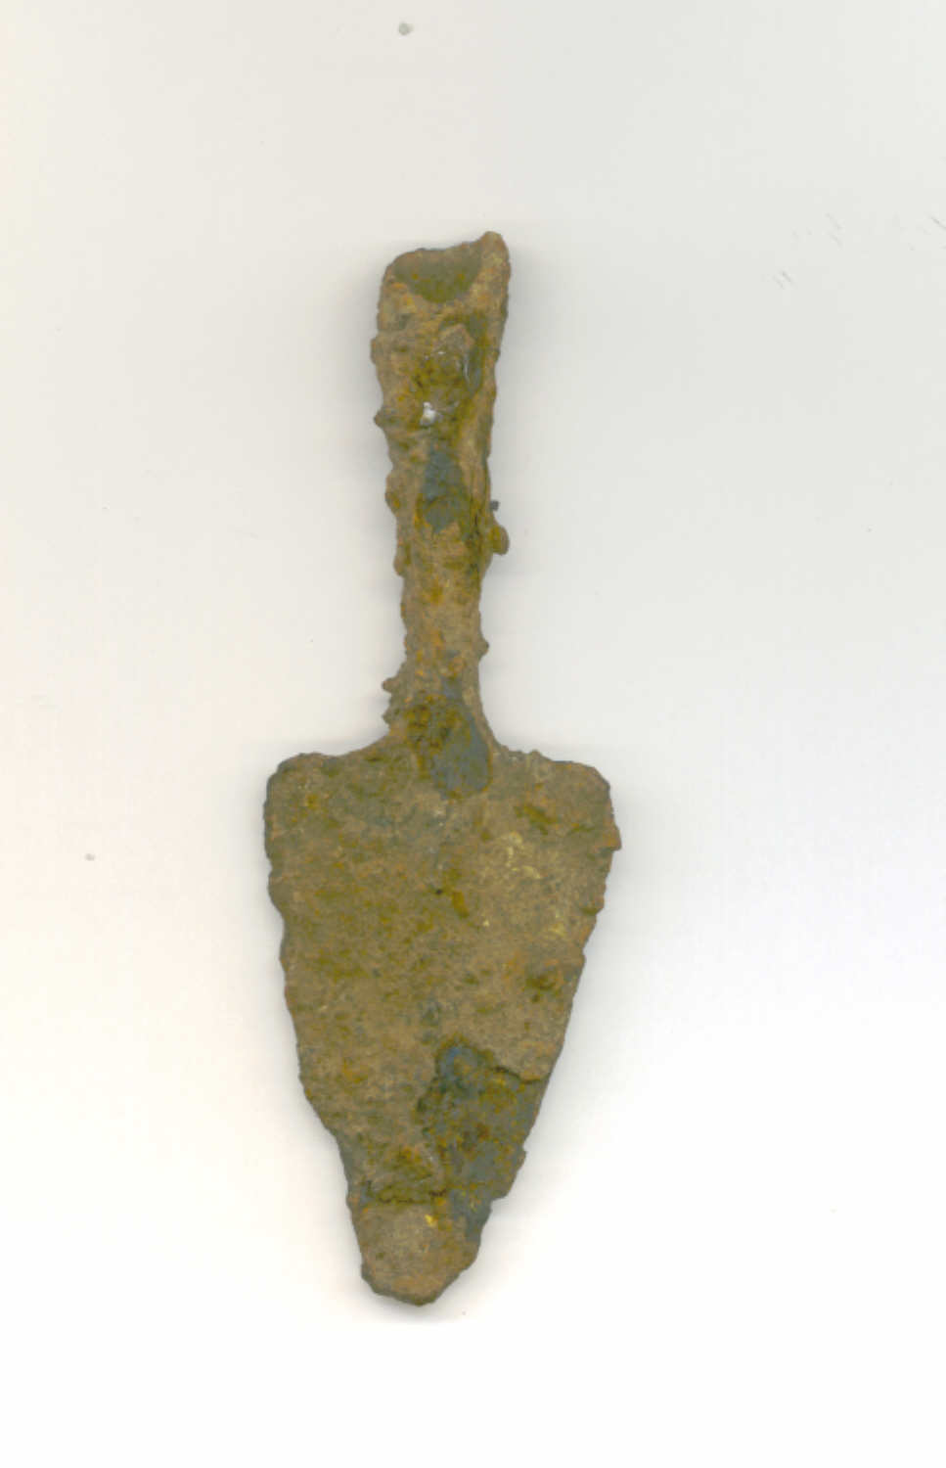
E Roans, Rouen in Normandy,
E Coras e Cans Cherbourg and Caen besides,
E tot a quan vol; And everything he wants,
Sai s’eslans Rushing there.

Clearly the reference to Titagrava^{rp2} was made primarily because the word ending suited the mechanics of the poem, however the name must still have been in use during the reign of King Richard for it to be used.
rp1 Yea –and-Nay was the nickname given to King Richard 1st. by Born
rp2 Keith Briggs of the English Place-name Society has confirmed to David Hinton the attribution of the name Titgrava to Tidgrove, He states I am happy that Titagrava is Tidgrove 1) The spelling is right for the date (1190) The context requires a royal estate 3 ) There are no other plausible options
The king’s houses built by Henry II seem to have been abandoned after the death of John since there is no further record of work done on them, but in 1251, as has been said, Henry III undertook the building, in Freemantle Forest, perhaps at Tidgrove, or as previously thought, at the top of what is now known as Cottington‘s Hill, a new hunting lodge in or adjacent to a park for fallow deer.
As can be seen from the Liberate Rolls this was on a large and expensive scale. When completed the king made little use of it and in 1256 gave it to his son the Lord Edward who was little more interested and in 1276 gave the houses to Pain de Chaworth with permission to pull them down and make what profit from them that he could. In the course of time the houses at Tidgrove were forgotten and only Cottington’s Hill was remembered as the site of King John‘s hunting park, this concept is now shown to be erroneous, firstly the park was not constructed until 1252-4 long after King Johns death, and secondly by the dated finds and physical remains on the site at Tidgrove which shows use well into 13th. century.

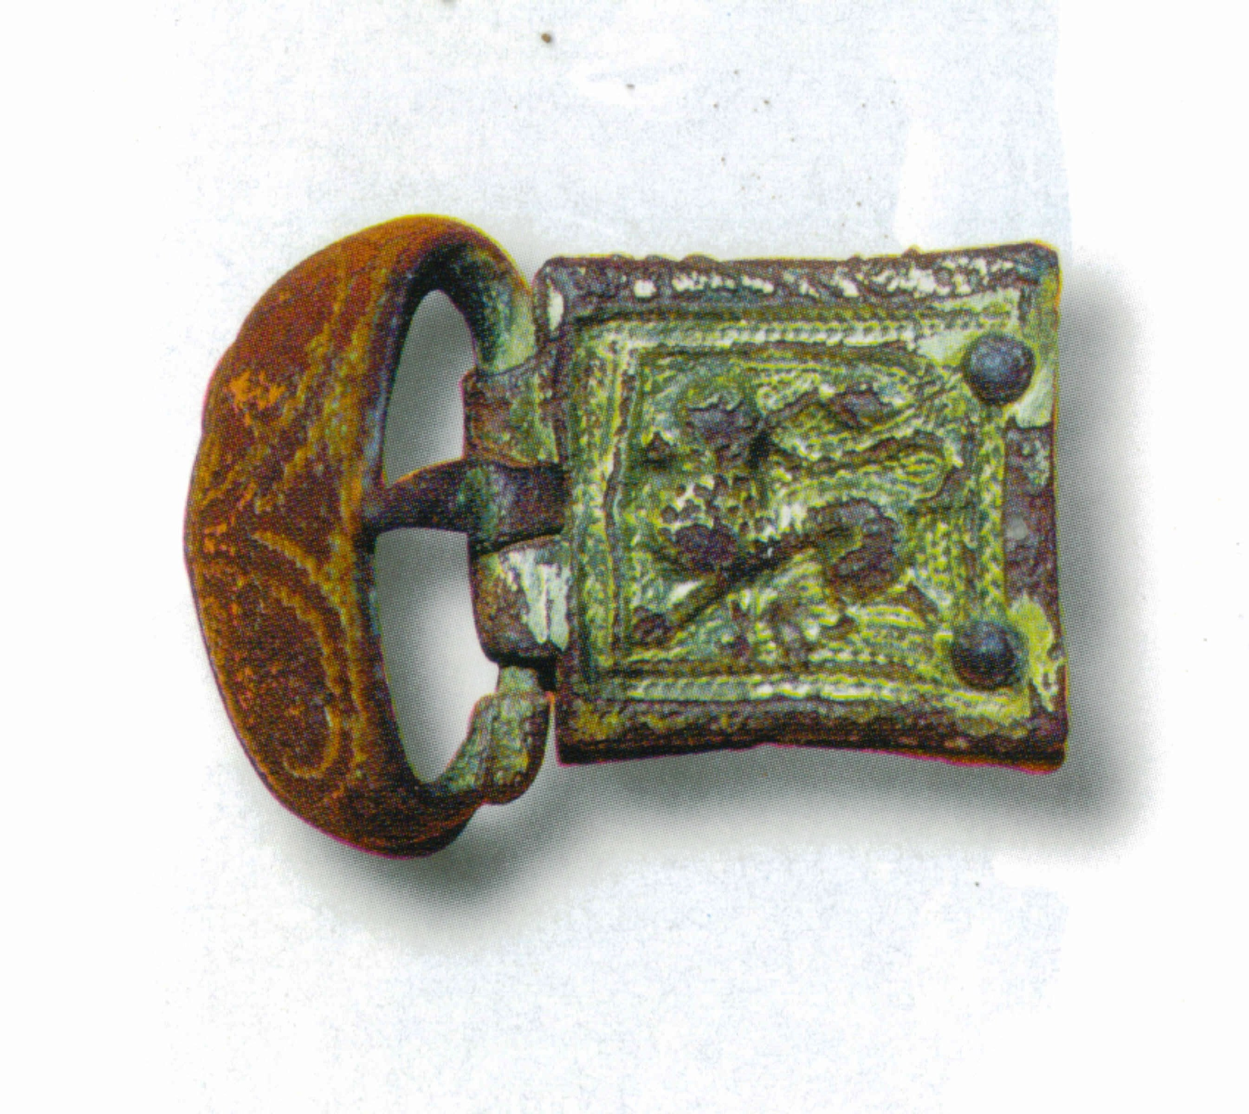
Visitors to Freemantle

Legend recounts that Rosamonde de Clifford had a bower at Freemantle

This of course is erroneous, the name Freemantle did not come into use until at least 15 years after her death in 1176 and a park for fallow deer within this forest was not created until 1253

Most likely her bower was in the nearby parish of Wolverton where we know Queen Eleanor had a house, again here was a park, at this time for Red Deer, when it was customary for houses to be outside the paled enclosure, evidence suggests that the Queens house and that used by Rosamonde after the Queens imprisonment were one and the same and was located just north of the park at a place called Sandford de Knolle, the site of the present day Sandford Springs Golf Course and Knowl hill House.

King Henry ll actually acquired land here after Rosamondes death and gave it to the Nunnery at Godstow (Oxon) where Rosamonde died, too big a coincidence. Her death in 1176 at the young age of 25-6 was most likely due to childbirth, her parentage of William Longespee has been recently challenged by the discovery of a charter by him stating his mother was Ida de Toeny, this charter was dated after Ida’s death and may have been influenced by his claim to her estate. A more likely scenario is that Rosamonde’s orphaned child was given to Ida to bring up, Ida was as well the name of the Abbess of Godstow around this time
Only DNA tests on the relevant descendants will settle the matter

For the names of other important visitors we have to rely on lists of witnesses attached to charters. Unfortunately none are known to have been issued at Freemantle in the time of Henry II, but in the reign of Richard there were four issued between 27 and 30 October 1189, in the name of the king while he was progressing round the south of England in the months between his coronation and his departure for France and thence the crusade. They are given under the hand of William Longchamp, Richard’s chancellor and bishop elect of Ely. One concerns a grant for the Bishop and cathedral of Coventry, the other three are all for Mountjoux hospital in the Alps. In all there are only seven witnesses including the bishops of Durham and of Bath, Stephen Longchamp (the brother of William ?), and William Marshal, then a rising star On 30 October, the queen mother, was also at Freemantle. The only recorded visit of Richard was on 14 April 1194.
Rather more interesting is an account for supplies of Hugh de Neville who was a visitor at Freemantle when King John and queen were there for a week in March or April 1207, and then went on to Clarendon. Hugh was the master of the royal hounds, chief justice of the forests and an influential adviser of the king...How far this accounts represent payments on behalf of the monarch by Hugh, acting as steward and butler, is not entirely clear and is somewhat confused because many of the supplies mentioned were from stock at Freemantle, and it may be that he is accounting for supplies for himself and his retinue whilst he was there. The account, in a free translation, is given in the following appendix.

Simplified version of Hugh de Neville’s account.
( translation RRL}

Freemantle. Thursday, Friday, Saturday when the king was there.
Bread 15s.
[ ] quarters of flour from the caterer [butler ?] for the king’s bread 9 s. 8 d.
All the course flour is still in stock.
2 tuns [casks] of ale from stock
600 herrings from stock.
Reeds for three days 6 s.
11 ½ quarters of fodder from stock
All paid by the hand of J de Sell‘.
Freemantle. Sunday
Bread 4s. 2d.
Ale 3s. 3d.
Herrings 4s.
All paid by J. de Sell’

Freemantle. Monday
Bread 4s. 6d.
Ale 3s. 3d.
Plaice (?) 12d.
Reeds 2s. 2d.
Carriage 20d.
7½ quarters of fodder from stock for two nights for the horses of Thomas Esturm
A [[t]un] of wine 8 d.
400 herrings for two days.
Paid by John de Sell’. (bracketed against all the above in another hand.)
Total sum for the five days 52 s. 19 d. The whole was paid by J. de Sell’.

Wigton. Tuesday
Bread 5½ s.
Ale 16d.
Herrings 10½ p.
Salmon and sechiis (?) 23d.
Firewood 8d.
Hay 12d.
Herrings 3s. 11d.
Letter/charter 19½ d.
Horse-shoes 11d.
Total 17s. 9d.
Item for expenses Adam Cisun with herrings 5s. 6½d
Wednesday - we were that night at Lockerley
Bread 4s. 6d.
Hay 4d.
Firewood 3d.
200 herrings 24d.
Raies (?) 18d. Must (unfermented wine) and herrings and the hall 2d
Whelks 8d. Horse Shoe 1d Wine from Winton 28d Total 12s
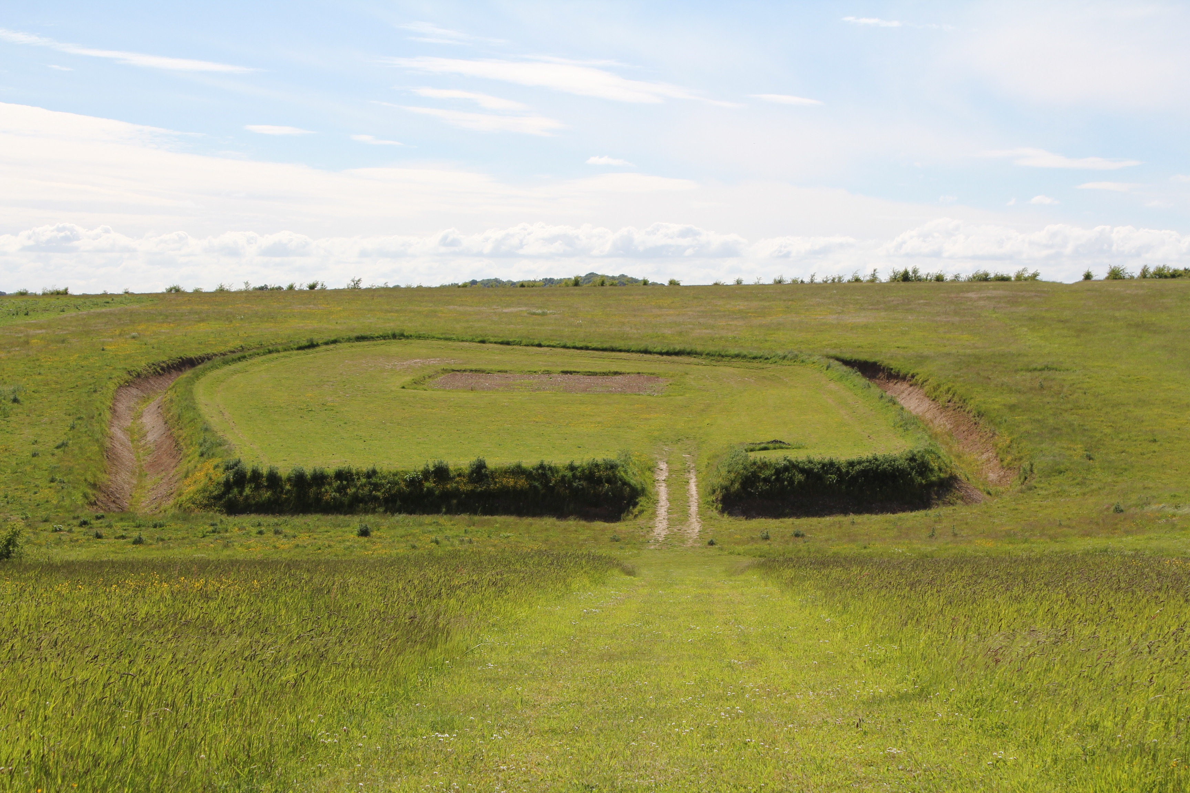
View showing enclosure approaching from east 2013

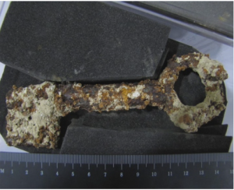

Key to Cellar see Grant Cox Media website

Handbook of British Chronology, (3rd edition) Royal Historical Society, 1985, p. 36.
For reasons given later it is assumed that Freemantle is simply a new name for Tidgrove.
Warren, Henry II, p. 254.
Dialogu de Scaccarioo, and Constitutioo Domus Regis; The dialogue of the Exchequer, and the Establishment of the Royal Household, ed. Emilie Amt and S.D. Church, [Oxford Medieval Texts, Sep. 2007].
Bartlett, England under the Norman and Angevin Kings, (OUP, 2000), p’ 133.
Peter of Blois, letter no. 66 in electronic medieval source book.. Quoted, Warren, op. cit., pp. 209-210.
Pipe Roll 18 Henry II, p. 76. [Michaelmas 1172.
Colvin, The History of the Kling’s Works, vol. I, p. 52, citing Rotuli de Liberate (Rec, Comm.) p.76. This is the earliest writ of its kind whose text has been preserved
Pipe Roll 23 Henry II, p. 166.
Pipe Roll 24 Henry II, p. 106.
Colvin, The King’s Works, pp. 940-1.
Ibid.
Ibid.
Richard Coates, Hampshire Place Names, pp. 79-80.
Pipe Roll 27 Henry II, p.136. [Michaelmas 1181].
R. W. Eyton, Court, Household and Itinerary of King Henry II, pp. 220-1.
W. L. Warren, Henry II, p. 585.
Ibid. p.212.
Eyton, op.cit. p. 231.
Colvin, op. cit. p. 941.
Personal communication from Dr Judith Everard, editor of the Acts of Richard I , to be published shortly by the Royal Historical Society.
The Itinerary Of King Richard I, Pipe Roll Society, 1935, p. 13.
Ibid. p. 88.
C.M. Woolgar (ed.), Household Accounts From Medieval England, part 1. p.113.

